

**OXFORD DAY**

**SATURDAY APRIL 22nd**

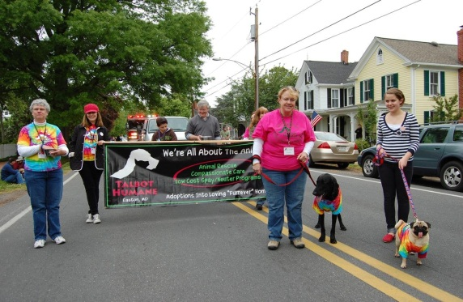

***Join the fun on Saturday, April 22nd in Oxford for a Dog Walk and Show to benefit the animals of Talbot Humane. Talbot Humane provides a safe and health and healthy environment for unwanted companion animals in its care; places adoptable companion animals in good homes; protects all animals from cruelty and neglect; and reduces the unwanted companion animal population through spay/neuter services.***

**D o g W a l k R e g i s t r a t i o n**

**Please bring registration form the morning of the walk. Registration fee = $25.**

**Can’t make it and want to “virtually walk” from home? $20 donation to Talbot Humane PO Box 1143 Easton 21601 or visit us at** [**www.talbothumane.org/donate**](http://www.talbothumane.org/donate)

**8:00 – 8:45 am Registration**

**8:55 am Blessing of the Dogs by Father Kevin Cross**

**9:00 am Dog Walk begins from registration point**

Name _________________________________________________________________________

Mailing Address: ____________________________________________

City: ________________________________ State: _______ Zip: ________

Home Phone: ___________________________Cell phone: _____________________________________

Email address: _________________________________________________________________________

Dog’s name: _________________________________________________________________________

**Waiver: In consideration of acceptance of my entry, I, my executors, administrators, or assignees, do hereby release and discharge Talbot Humane, and other sponsors, for any claims of damages, demands, actions whatsoever, in any manner arising out of my participation in said fund raising event. I attest and verify that I have full knowledge of the risk involved in this type of event, and I am physically fit and sufficiently trained to participate in this event.**

**Participant’s signature: ___________________________________________________________________ Date:________________**

**Parent Signature Required of Participants under 18:______________________________________________________________________**