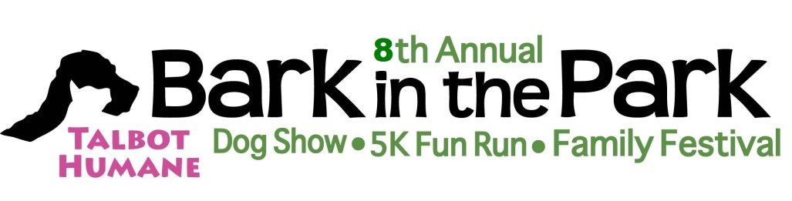

Can you believe Bark in the Park is revving up for our 8th year? We are once again asking for your help and support. The Dog Show is a wonderful way to promote your business and help the animals!

Date: October 14, 2017 Place: Idlewild Park
What is included with your Dog Show support? We will hang your banner in the Event Ring and your business will also appear in the program of BITP. We will announce your name and business when your sponsored class is held as well as provide a place for spectators to pick up your handouts.
Questions please call Patty Quimby (410)822-0107 or patty@talbothumane.org
Here are the following opportunities:
Lead Dog Dog Show: $500.00
Trophies: Salisbury Gift and Garden Ribbons: $150.00 For all classes and participants
Paw-rade of adoptable dogs (All shelters at Bark in the Park are encouraged to show their dogs) Ring master

Dog Show Sponsorship for all classes and Paw-rade: $125.00
Paw-rade of Adoptable dogs
Class 1– Tallest Dog Class 6– Look A-like
Class2– Fluffiest Dog Class 7– Dogs adopted from other organizations
Class3– Smallest Dog Class 8– Best Trick or talent
Class 4– Most Adorable Puppy Class 9- Unique Looks
Class 5– Dogs Adopted from Talbot Humane Class 10– Best Costume/Design
BEST OF SHOW

Please return this form with your class choice. I will try to honor your choice but it is on a first received basis.

Name: Telephone:
Business: Name of Person judging:

Sponsor 1st Choice: or 2nd Choice:

We will need your banner the morning of BITP by 7:30AM or you can drop it off at Talbot Humane by Thursday October 12th.

Please return this form and your check to: Talbot Humane Attn: Dog Show Sponsorship, P.O. Box 1143, Easton, MD 21601
Talbot Humane is a 501c3 Organization – PO Box 1143, Easton, MD 21601 – 410/822-0107

**If you are interested in other ways to support the event and the shelter, please contact me at (410)822-0107 or via email at patty@talbothumane.org. I will be happy to explain more opportunities for printed and radio advertising.

